FURTHER EDUCATION AND TRAINING CERTIFICATE: INFORMATION TECHNOLOGY: SYSTEMS DEVELOPMENT
ID 78965 LEVEL 4 – CREDITS 165
FACILITATOR GUIDE
SAQA: 14927
APPLY PROBLEM SOLVING STRATEGIES


Facilitator Information:

Details | Please Complete this Section
Name & Surname:
Organisation:
Unit/Dept:
Facilitator Name:
Date Started:
Date of Completion:

Copyright
All rights reserved. The copyright of this document, its previous editions and any annexures thereto, is protected and expressly reserved. No part of this document may be reproduced, stored in a retrievable system, or transmitted, in any form or by any means, electronic, mechanical, photocopying, recording or otherwise without the prior permission.
Facilitator Guide Introduction
About the Facilitator Guide… | This Facilitator Guide provides a comprehensive overview of APPLY PROBLEM SOLVING STRATEGIES, and forms part of a series of Facilitator Guides that have been developed for  The series of Facilitator Guides are conceptualized in modular’s format, in accordance with the Learner Guides. This guide has been designed and developed to assist you in effectively and efficiently prepare and implement your various training interventions.
Purpose | The purpose of this Facilitator Guide is to assist facilitators in delivering training sessions, related to  . The Guide also provides information on facilitation methodologies and strategies to be adopted during training sessions.
US No | US Title |  | Level | Credit
14927 | Apply problem solving strategies |  | 4 | 4
Objectives | - Apply problem solving strategies
Outcomes | The qualifying learner is capable of:  - Apply problem solving strategies
Facilitation Methodology | The programme is very practical and aims to provide practical tools and skills for adult learners. The methodology should ensure that:  - The learning environment is physically and psychologically comfortable.  - Contact training periods are short and varied to avoid boredom.  - Learner expectations are articulated and clarified and managed by the learner and facilitator.  - The experience of participants is acknowledged and drawn on in the learning programme.  - Facilitation, rather than teaching, is used to allow participants to participate fully.  - The facilitator balances the presentation of new material, debate and discussion in such a way that the outcomes of the module are met, while ensuring that all participants are valued and are able to contribute to the learning process.  - The learning will be problem-oriented, personalized and accepting of participants’ needs for self-direction and personal responsibility.  - The module presented in a way that allows a participant to participate fully in the language of their choice.  - The facilitation process accommodates participants who may not be literate, or who are not literate in English.  The contact session uses a participatory methodology. This is appropriate for adult audiences who come with a wide range of experiences and skills. It also accommodates a broader range of learning styles. Some techniques that can be used include:
  Method | Description
  Structured learning experience | Participants engage with a complex game or activities that represent real-life situations that they may encounter in the course of their work as a Ward Committee member.
  Case study | This is a realistic story or real-life situation that has taken place, in which participants need to apply their knowledge and skills to practice how they can deal with the issues presented.
  Group work | Participants work on tasks in their groups and report their findings back to plenary.
  Lecture | The facilitator presents a short talk (maximum of 10 minutes) to introduce a new subject, to provide details, or to wrap up a session.
  Discussion | This is a free exchange of ideas or experiences on a particular topic. It may be between the facilitator and the participants or between the participants.
  Brainstorming | Participants generate a number of ideas on a particular subject or question. It may be used to gather different opinions or to find out what participants know about a particular topic.
  Role-play | Participants are asked to act out a scenario where each participant plays a particular role. A role-play may be used to illustrate how people respond in different situations.
  Panel discussion | This is a planned presentation by one or more experts. It may be followed by a discussion session or a round of questions.
Resources | - White board and/or Flipcharts  - Laptop & Data Projector (not compulsory)  - Facilitator & Learner Guide  - Learner Workbook  - Appendices (attached to learner guide)
Time | Contact/ Facilitation Days
Time | Theory
Time | Practical
Time | Assessments
Time | Workplace Application Days

Facilitator’s Checklist & Training Aids
Learner support strategies:
Learners are supplied with all resources and aids as required by the program – including:
- Objects & devices such as equipment, protective clothing, and safety gear, etc.
- Learner Guides and Learner Workbook
- Visual aids, etc.

Use this checklist below during your preparation to ensure that you have all the equipment, documents and training aids for a successful session.

Preparation: | Yes | No
Qualification Knowledge – I have familiarised myself with the content of the applicable qualification
Unit Standard Knowledge – I have familiarised myself with the content of all aspects of the applicable unit standard
Content Knowledge – I have sufficient knowledge of the content to enable me to facilitate with ease
Application knowledge – I understand the programme matrix & have prepared for programme delivery accordingly
Contextualisation – I have included information which is specific to the commodity and practices related to the commodity
Ability to respond to learners background & experience – I have studied the learner demographics, age group, experience & circumstances & prepared for programme delivery accordingly
Enthusiasm & Commitment – I am passionate about my subject & have prepared my programme delivery to create a motivating environment with real commitment to success
Enterprise knowledge – I know & understand the values, ethics, vision & mission of the workplace & have prepared my programme delivery, reporting & administrative tasks accordingly.
Equipment check:
Learner guides x 1 per learner
Assessment guides x 1 per learner
Writing materials & stationary (facilitator & learner)
White board & pens
Flip chart paper
Proximal projector & screen
Laptop & programme disk
Sample Hand-outs and examples of laws and other relevant documents
Safety gear as prescribed by unit standard and applicable legislation
Documentation checklist:
Attendance Register
Course Evaluation
Learner Course Evaluation
Portfolios of evidence

Learning Program Time Frames
 | Total time allocated (hours) | Theoretical learning time allocated (hours) | Practical learning time allocated (hours) | Activities to be completed
Complete Program (including summative assessment)
Learner Orientation and “Ice Breaker” | 1 hour | 30 minutes | 30 minutes
Purpose, Introduction and Learner Directions | 1 hour | 30 minutes | 30 minutes
APPLY PROBLEM SOLVING STRATEGIES | 80 hour | 24 hours | 56 hours
Preparation for Assessment & revision | 0.5 | - | - | -

TRAINING PROGRAM

Briefing Session: Day1

1. Introduction to the Learning Units

 | Start with an “ice-breaker”, and eventually discuss the global outcome of the learning units with learners and emphasize the assessment process.
 | Topics | Time | Remarks
 | - Ice Breaker  - Course expectations  - Assessment Criteria  - Learner’s Responsibilities | 15 min  10 min  5 min | Please refer to Learner Guide and Assessment Guide for details.

2. Training Ground Rules
 | Discuss the training session ground rules with learners to avoid disturbance during the session
 | Topics | Time | Remarks
 | - Learning Units estimated time  - Ethical behavior  - Cellular phones – (off/silent)  - Breaks – (tea, lunch….)  - Etc… | 10 Min | Write down the training session ground rules and keep them posted in the classroom for the duration of the session.

WORKBOOK MEMORANDA

Learning Unit1
Apply problem solving strategies

UNIT STANDARD NUMBER : 14927
LEVEL ON THE NQF : 4
CREDITS : 4
FIELD : Physical, Mathematical, Computer and Life Sciences
SUB FIELD : Construction Information Technology and Computer Sciences

PURPOSE: | This unit standard is intended:  to provide fundamental knowledge of the areas covered  for those working in, or entering the workplace in the area of Business and Organisational Communication  as additional knowledge for those wanting to understand the areas covered  People credited with this unit standard are able to:  Define and analyse the problem  Evaluate solutions  Implement the solution  The performance of all elements is to a standard that allows for further learning in this area.
LEARNING ASSUMED TO BE IN PLACE:
The credit value of this unit is based on a person having prior knowledge and skills to:
Demonstrate an understanding of fundamental mathematics (at least at NQF Level 3)
Demonstrate competence to communicate in English (at least at NQF Level 3)

SESSION 1.
Define and analyse the problem.
Learning Outcomes
- 1. The definition ensures that the problem is examined and identified in terms of problem type, problem parameters, and possible causes
- 2. The definition ensures that facts are collected to meet the problem requirements
- 3. The analysis ensures that problem components are identified to determine possible courses of action
- 4. The analysis ensures that the problem is analysed for cross-cultural implications

Activity | Questions Description | Mark
1 | Identify causes of problems in the workplace | 5

- People
Are there enough participants to help?
- Are the participants' skills adequate?
- Are some participants perceived as not helpful?
- Resources
Are there enough, for example funding?
- Are some not identified?
- Are some not used effectively, or mis-placed?
- Environment
Is it conducive to problem solving? Is there too much stress?
- Is the power structure (administration or line of authority) supportive?
- Is the power structure (administration or line of authority) aware of the problem?
- Processes, procedures and rules
- Are they understood, or badly defined?
- Are they perceived as an obstacle?
- Vocabulary/terminology/concepts
Is there an agreed-upon vocabulary, and understanding of their meanings and definitions?
Are some "hidden"?
Working with the diagram:
- Consider all the causes and rank them in importance
- either on their post-its, or by circles with numbers etc.
- Examine relationship

Activity | Questions Description | Mark
2 | Draw a Map showing the problem solving process | 10

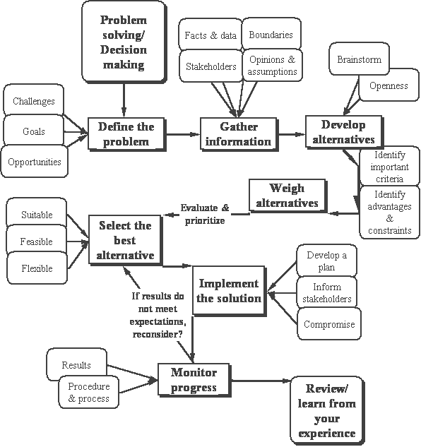

Activity | Questions Description | Mark
3 | List factors that can contribute to solving the problem | 5

The time
- When exactly does the problem occur?
- When exactly is it at its worst?
- When does it not occur?
- Can you identify a pattern from this information?
The place
- Where exactly does the problem mostly occur?
- Where does it not occur?
- Can you identify a pattern?
The sequence
- What exactly is happening before the problem occurs?
- How exactly does the problem start?
- What is happening for the problem to continue?
- What exactly was your train of thought?
- What are you doing/feeling/seeing/hearing?
- Can you identify a pattern?
Other people
Friend or foe - how are they detracting from or contributing to your problem and problem solving strategies?
- What significant people are present or absent when the problem occurs?
- What do others/your partner/friend/colleague/family think about the problem?
- Who doesn't know about the problem and should know?
- What do you anticipate they might think when they find out?
- Can one of them act like the 'devil’'s advocate' to give you a completelydifferent perspective?

SESSION 2.
Evaluate solutions.
Learning Outcomes
- 1. The evaluation identifies possible solutions to the problem by using a range of problem solving techniques
- 2. The evaluation establishes criteria for evaluating solutions to match the type of problem
- 3. Possible solutions are evaluated against established criteria
- 4. The evaluation ensures that solutions are selected to meet established criteria and problem requirements

Activity | Questions Description | Mark
4 | Outline the importance of evaluating your resources and strengths in solving the problem | 3
- What parts of your role as a partner/colleague/employee/employer areworking well?
- What exactly are you doing that makes it work well?
- What skills and resources do you use in your spare time and at work?
- What are your achievements? (This could be large ‘one-offs’ or every day ‘small’ ones, for example passing your driving test, getting your PhD or cooking a meal)
- Who has solved a similar problem? How did they do it?
- Who can help and/or advise you whilst staying objective?
- Who can support and encourage you whilst staying objective?
- What would you consider to be ‘life's little treats’? (e.g. a hot bath, first flowers in spring, looking at art, reading an inspiring book, etc.) It's vital to be aware of the things you consider to be treats when you want to recharge your energy!
Beyond the problem
- What would you be doing/concentrating on if you didn't have the problem?
- How exactly would you and/or the situation be different?
- What would your friends/family/colleagues notice about you/the situation?
- What would happen if you just ignored the problem?
- Could you view the present situation - although clearly not ideal - as analternative solution?
- Are there any possible benefits to the situation?
- Can you make any changes, without having to solve the problem first?
- How would you ideally like it to end?
- What small steps can you take towards an eventual solution or part-solution?
- What can you do today that will make a difference tomorrow?
- Are there any other opportunities to turn a negative in a positive?
- What will you settle for if all else fails?

Activity | Questions Description | Mark
5 | Demonstrate understanding of how to develop/weigh alternatives | 7
Look at your problems in different ways; find a new perspective that you haven't thought of before. Brainstorming, or rapid noting of alternatives no matter how silly, is an excellent discovery process. Once you have listed or mapped alternatives, be open to their possibilities. Make notes on those that:
- need more information
- are new solutions
- can be combined or eliminated
- will meet opposition
- seem promising or exciting
Weigh Alternatives
After listing possible alternatives, evaluate them without prejudice,
no matter how appealing or distasteful
Consider all criteria While a suitable solution may solve the problem, it may not work if resources aren't available, if people won't accept it, or if it causes new problems
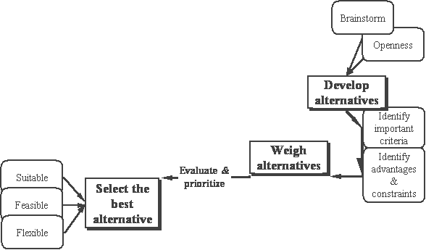
Select the best alternative
- Don't consider any alternative as "perfect solution."
- If there were, there probably wouldn't be a problem in the first place
- Consider your intuition,
- or inner feelings in deciding on a course of action
- Return to your trusted outsider:
- Is there something you missed?
- Does he/she see a problem with your solution?
- Compromise
Consider compromise when you have a full grasp of the problem, and your alternatives. Competing solutions may yield a hybrid solution.
Techniques in weighing alternatives:

SESSION 3.
Implement the solution.
Learning Outcomes
- 1. The implementation ensures that solutions are trialed and/ or monitored for effectiveness of problem solution
- 2. The implementation ensures that solutions are reviewed and modified, and practices are standardised where required
- 3. The implementation ensures that stakeholders are consulted during implementation

Activity | Questions Description | Mark
6 | Describe how to implement the problem solving solution. | 10
Elements:
- Step-by-step process or actions for solving the problem
- Communications strategy for notifying stakeholders Where important or necessary, inform those who care for you and/or will be affected by the change. Prepare them as necessary about your decision
- Resource identification/allocation
- Timeline for implementation
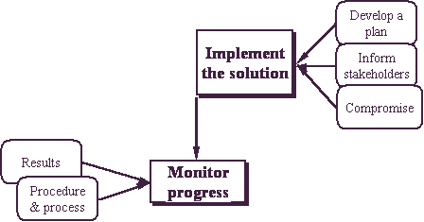
Monitoring progress
Your implementation will only be successful if you are monitoring your solution, the effects of it on resources and stakeholders, your timeline, and your progress. As you monitor your progress, if results are not what you expect, review your options and alternatives.

Whether or not you achieved your goals, it is important to consider what you have learned from your experience: about yourself, about what you consider important.
Lastly, if you have done your best,you have this as one measure of success.

IMPLEMENTATION Summary
The last step is to implement the solution you have chosen. This step involves identification of all the steps necessary to implement it, and also on-going monitoring of the effectiveness of the solution to make sure that it actually solved the problem. During this stage of the process, ask yourself the following questions:
- How effective is the solution?
- Did it achieve what I wanted?
- What consequences (good and bad) did it have in my situation?
If the solution was successful in helping you solve your problem, then you can feel satisfied with your efforts and what you learned. If you feel dissatisfied in some way, you can either modify the solution to work better, or you can scrap it and turn to other alternative solutions, or begin the process again. Remember that problem-solving is a cycle – it involves searching for a solution to a problem that will lead to various possible solutions which then need to be evaluated. If the problem is solved, then you have found an effective solution. If the problem has not been solved, then you start the process again.

